[DDCFUN-31] (S054) Change Steps

Jason Chen

May 13, 2019

[DDCFUN-31] Pick by Order workflow should show Container instead of Tag (S054)

TST-421286

RLS-433130, RLS-445554

This document describes the steps of making the change manually in WMS:

1. In WMS, go to view Workflows.
2. Search for Workflow Name = wms_pick_by_order.wf

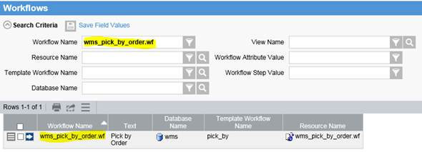

1. Go into details of wms_pick_by_order.wf
2. Change the value of Workflow Attribute pick_workflow to “wms_pick_ldb.wf”.

